**VISVESVARAYA TECHNOLOGICAL UNIVERSITY**

**BELAGAVI, KARNATAKA**



**Mini Project Report**

**On**

**“ ALUMNI DATABASE MANAGEMENT ”**

**Submitted to**

**Department of**

**Computer Science and Engineering**

**BY**

**Niveditha G 3vc17cs060**

**Under the Guidance of**

**K.S.Aparna M.Tech, MISTE**

**Sarvar Begum M.Tech**

**Assistant Professor,**

**CSE Department, RYMEC**



**DEPARTMENT OF COMPUTER SCIENCE & ENGINEERING**

**RAO BAHADUR Y.MAHABALESHWARAPPA COLLEGE OF ENGINEERING**

**BALLARI - 583104, KARNATAKA**

**2019-2020**

ACKNOWLEDGEMENT

I would like to express our regards and acknowledgement to all those who helped in making this detailed project report possible.

I am grateful to the principal, DR. K. Veeresh for providing facilities and untiring zeal, which constantly inspired me towards the attainment of everlasting knowledge throughout the course.

I am deeply indebted to Dr.H.Girisha, HOD of computer science and engineering department for the valuable suggestions and constant encouragement provided for the successful completion of mini project report.

I would like to thank our guide, K.S. Aparna and Sarvar Begum, assistant professor of computer science and engineering department for the constant guidance for the successful completion of mini project report.

Finally, I would like to thank all the staff members of computer science and engineering department for their guidance and support. I am also thankful to my family and friends who continue to give me best support.

**CHAPTER NO /TITLE PAGE NO.**

**1. INTRODUCTION 02**

**1.1 OBJECTIVES 02**

**1.2 LIMITATIONS 02**

**2. DATABASE DESIGN 03-04**

**2.1 SOFTWARE REQUIREMENT SPECIFICATION 03**

**2.1.1 COLLECTION OF REQUIREMENTS 03**

**2.1.2 FUNCTIONAL REQUIREMENTS 03-04**

**2.1.3 SOFTWARE AND HARDWARE REQUIREMENTS 04**

**2.2 CONCEPTUAL DESIGN 04-05**

**2.3 LOGICAL DESIGN 05-06**

**2.4 IMPLEMENTATION 07-08**

**2.4.1 PRESENTAION LAYER (FRONT END) 07**

**2.4.2 MIDDLE LAYER 07**

**2.4.3 DATA BASE SERVICES LAYER (BACK END) 08**

**3. SNAPSHOTS 09-15**

**3.1 HOME PAGE 09**

**3.2 LOGIN PAGE 09**

**3.3 OPARATIONS PAGES 10-15**

**4. CONCLUSION 16**

**REFERENCES 17**

**Chapter 1**

**INTRODUCTION**

The application is a single user interface and provide accessibility only for the registered user . Present application supports user to perform their basic required operations such as inserting the details of alumni’s, deletion, updation, show alumni’s current status. Along with some search options, it also includes the displaying of details.

.

* 1. **OBJECTIVES:**

The objectives of Alumni Association are:

1. To keep a list of all Alumni of college and their relevant data.
2. Maintaining the updated and current information of all Alumni.
3. To provide and spread the information regarding from the course they have graduated , its graduates, faculties and students to the Alumni.
4. To assist and support the efforts of their college in obtaining funds for development.
5. To guide and assist Alumni who have recently completed their course of study at their college to keep them engaged in productive pursuits useful to the society.
6. To provide a forum for the Alumni for exchange of ideas on academic, cultural and social issues of the day by organizing and coordinating reunion activities of the Alumni.

The Alumni Association achieves these objectives by staging an annual programming of events and reunions; through communications.

* 1. **LIMITATIONS:**

1. Although I have my best efforts to make the application flexible, is to operate but limitations cannot be ruled out even by me. Though the application presents a broad range of options, it is only for single user.
2. Maintenance Issue: You might have to struggle with redundancies.

**Chapter 2**

**DATABASE DESIGN :**

The database-planning phase begins when a customer requests to develop a database project. It is set of tasks or activities, which decide the resources required in the database development and time limits of different activities.

**2.1 SOFTWARE REQUIREMENT SPECIFICATION (SRS):**

**2.1.1 Collection of Requirements:**

Requirements analysis is done in order to understand the problem, which is to be solved. That is very important activity for the development of database system. The requirements and the collection analysis phase produce both data requirements and functional requirements. The data requirements are used as a source of database design. The data requirements should be specified in as detailed and complete form as possible.

In parallel with specifying the data requirements, it is useful to specify the known functional requirements of the application. These consist of user defined operations that will be applied to the database (retrievals and updates).The functional requirements are used as a source of application software design.

**DATA REQUIREMENTS:**

The Data-requirements are given as follows:-

**User Module:**

* **User Login**
  + User can get into the database after Login.
  + User Login with User Name and Password.

**Admin login:** if admin login is successful then admin can insert, delete and update the house details.

**View:** The selected details will be displayed. Count is displayed along with the date and time.

**2.1.2 FUNCTIONAL REQUIREMENTS:**

1. Registered user can login to the system to perform different operation.

2. The system can verify the data before login.

3. The system can select, insert, update, delete according to the user requirements.

4. Procedures like stored procedures and triggers are added so that the user can use it in a very efficient manner.

**2.1.3 SOFTWARE AND HARDWARE REQUIREMENTS**

* Intel core i5 2nd generation is used as processor because it is faster & provide reliable and stable working environment.
* A RAM size of 4GB is used as it will provide fast reading & writing capabilities.
* Intel core i5 2nd generation is used as processor because it is faster & provide reliable and stable working environment.
* A RAM size of 4GB is used as it will provide fast reading & writing capabilities.
* Oracle 11g Express Edition
* Python
* PyCharm

**2.2 CONCEPTUAL DESIGN**

Once all the requirements have been collected and analyzed, the next step is to create a conceptual schema for the database, using a high-level conceptual data model. This phase is the conceptual design. The result of this phase is an Entity- Relationship (ER) diagram. It is a high-level data model of the specific application area. It describes how different entities (objects, items) are related to each other. It also describes what attributes (properties) each entity has. It includes the definitions of all the concepts (entities, attributes) of the application area.

**ER-Diagram:**

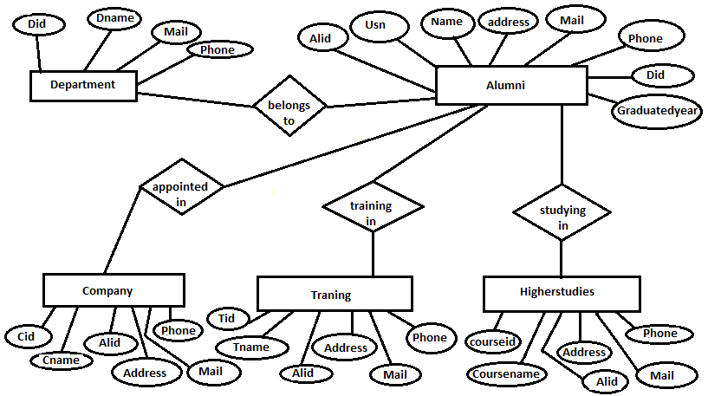

**2.3 Logical Design:**

There are rules how the ER model is transferred to relation schemas. The relation schemas are the basis for table definitions. In this phase (if not done in previous phase) the primary keys and foreign keys are defined. While preparing the logical design part, we applied relational data model.

Write appropriate steps for ER to relation mapping.

**To do this, we decided to use Oracle 11g.**

**Schema Diagram:**

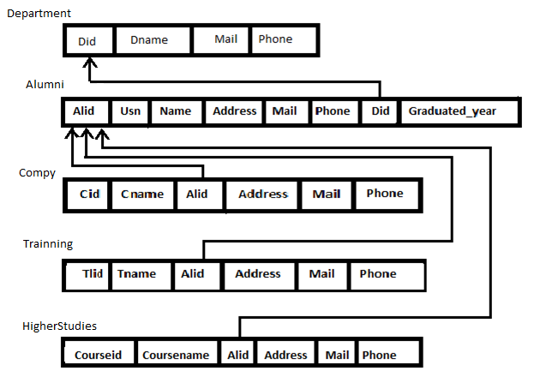

* 1. **IMPLEMENTATION**

The various system tools that have been used in developing both the presentation layer, middle layer and database layer of the project are being discussed in this chapter.

**2.4.1 PRESENTAION LAYER ( FRONT END):**

**HTML, CSS are utilized to implement the front end of the project:**

HTML (Hyper Text Markup Language): HTML is a syntax used to format a text document on the web. Hypertext Markup Language (HTML) is the standard markup language for creating web pages and web applications. With Cascading Style Sheets (CSS). Web browsers receive HTML documents from a web server or from local storage and render them into multimedia web pages. HTML describes the structure of a web page semantically and originally included cues for the appearance of the document.

CSS (Cascading Style Sheets): CSS is a style sheet language used for describing the look and formatting of a document written in a markup language. Cascading Style Sheets (CSS) is a style sheet language used for describing the presentation of a document written in a markup language.CSS is used to set the visual style of web pages and user interfaces written in HTML and XHTML. Along with HTML, CSS is a cornerstone technology used by most websites to create visually engaging web pages, user interfaces for web applications, and user interfaces for many mobile applications.

**2.4.2 MIDDLE LAYER:**

Flask is a popular Python web framework, meaning it is a third-party Python library use for developing web applications. The application is created with Python Flask as it’s middle layer and provide communication between the Frontend and the Backend. Web application developers typically write Python codes at backend that specially designed to handle HTML requests.

This command line uses the built-in Python compiler package for analysing Python source code at the Backend. For this Python Flask to work properly, you have to include the proper connection of the Python to the Backend database.

* + 1. **DATABASE SERVICES LAYER (BACK END):**

The back end is implemented using Oracle which is used to design the databases. Oracle is an open-source relational database management system (RDBMS). The SQL phrase stands for structured query.

An Oracle database is a collection of data treated as a unit. The purpose of a database is to store and retrieve related information. A database server is the key to solving the problems of information management. In general, a [server](https://docs.oracle.com/cd/B19306_01/server.102/b14220/glossary.htm#i432724) reliably manages a large amount of data in a multiuser environment so that many users can concurrently access the same data. All this is accomplished while delivering high performance. A database server also prevents unauthorized access and provides efficient solutions for failure recovery**.**

**CHAPTER 3**

**USER INTERFACES :**



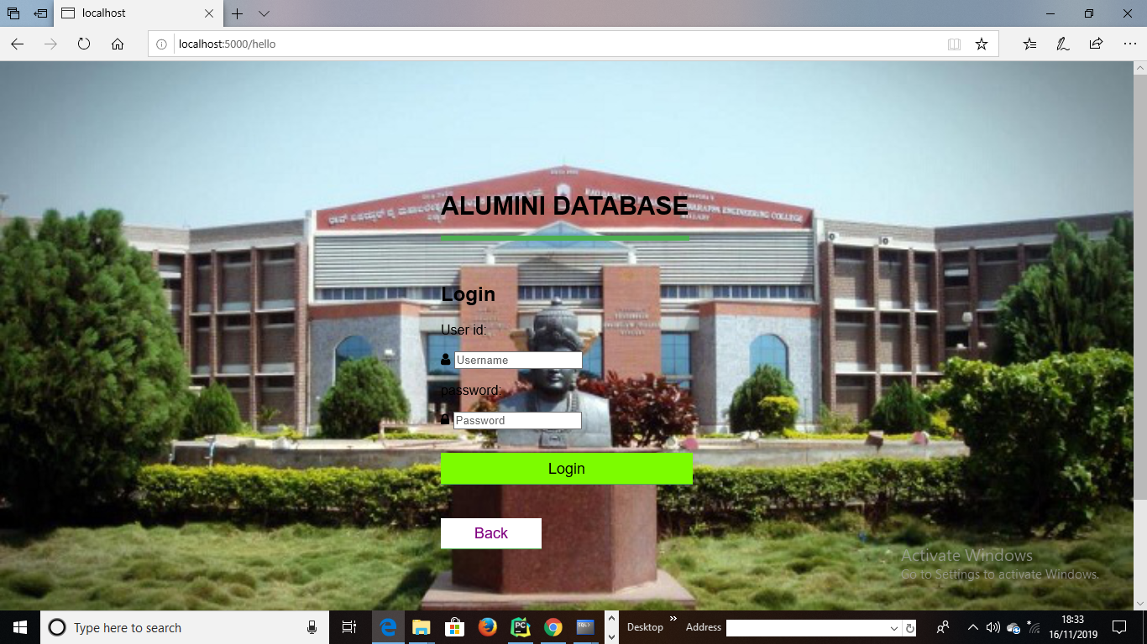

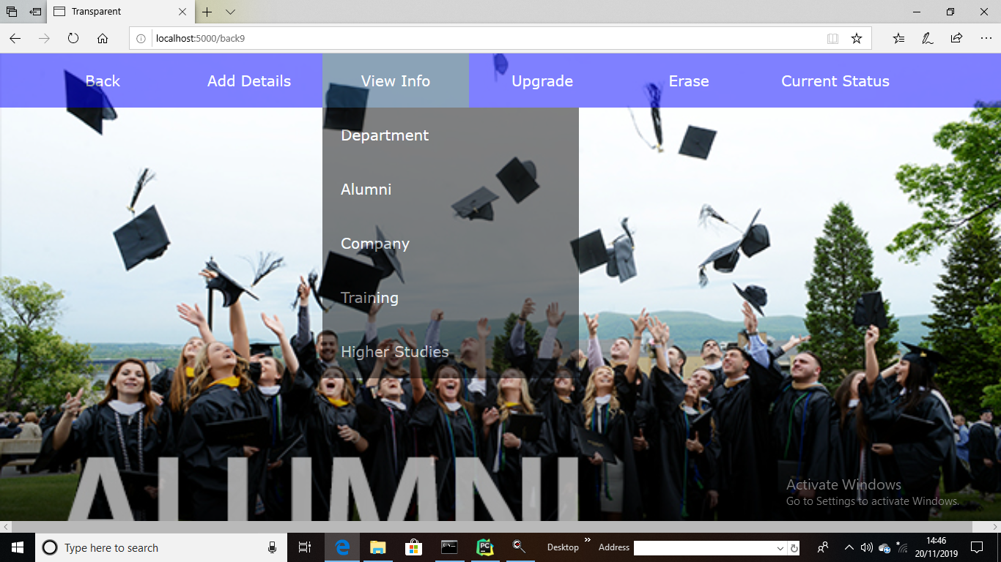

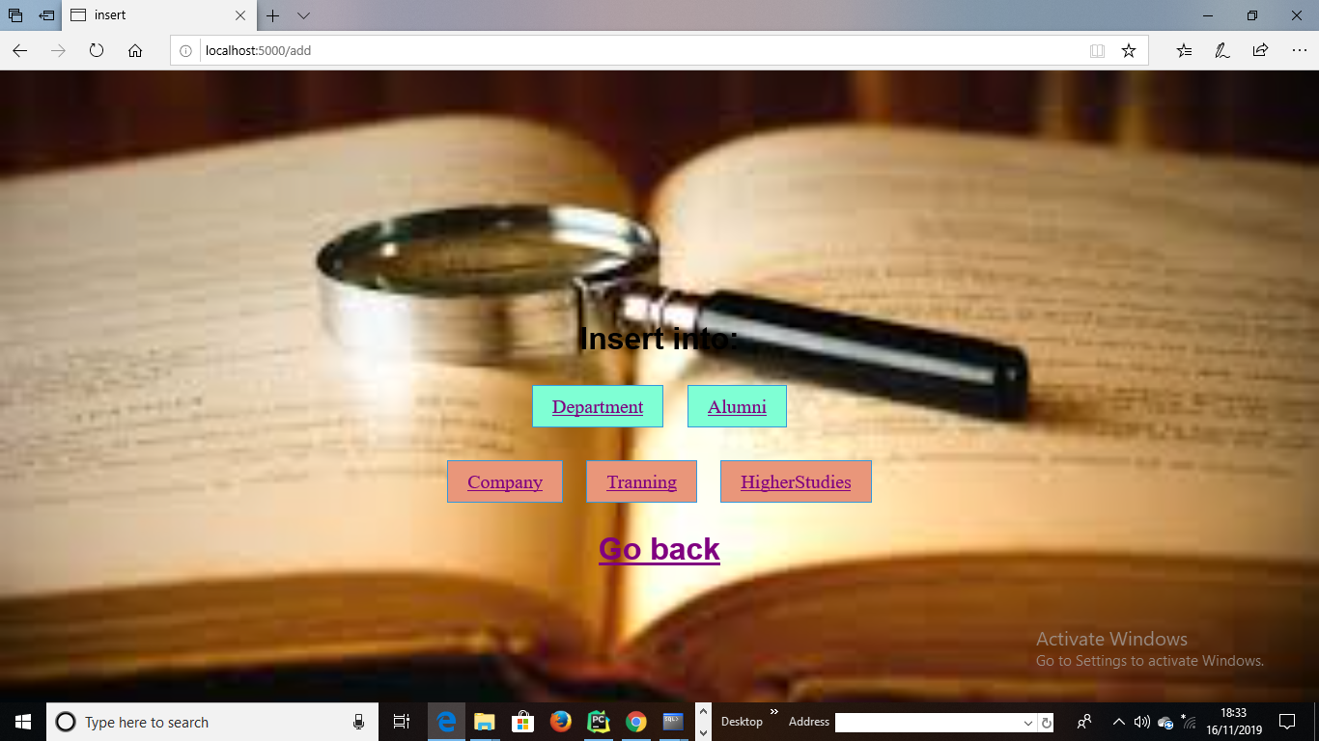

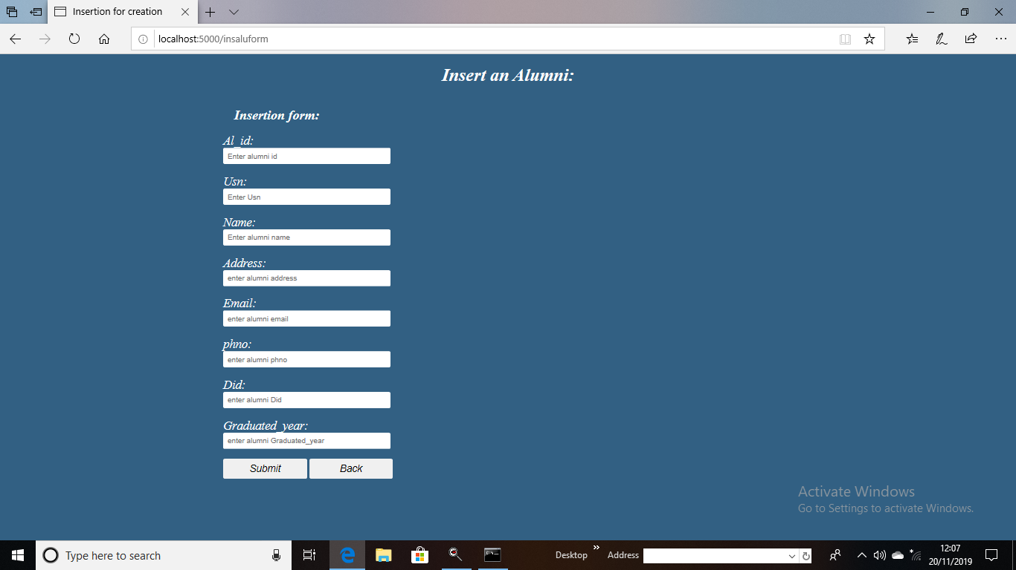

**­­**

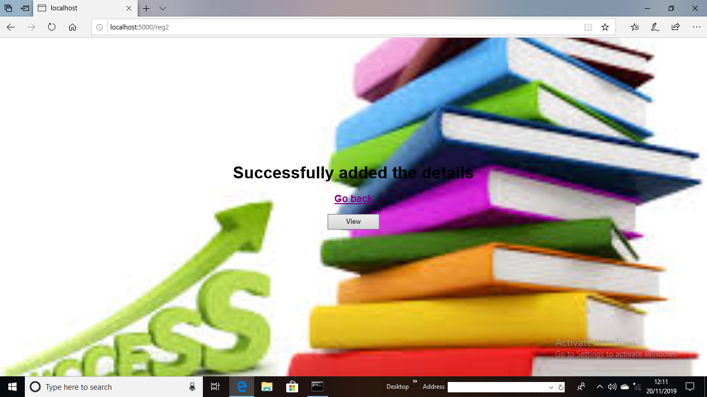

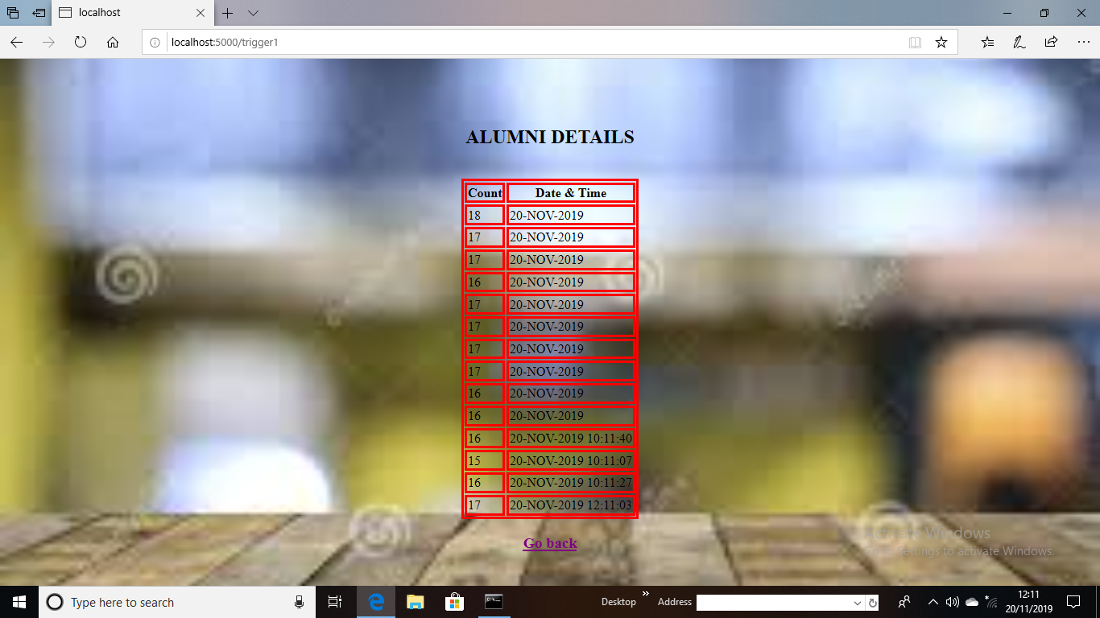

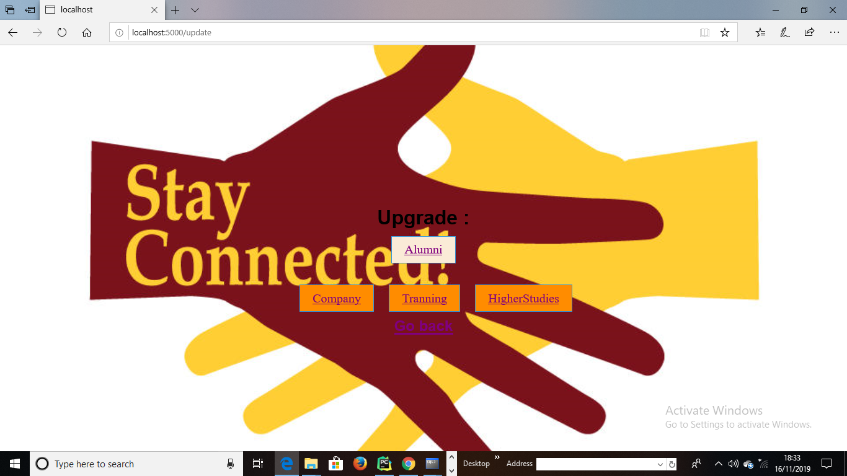

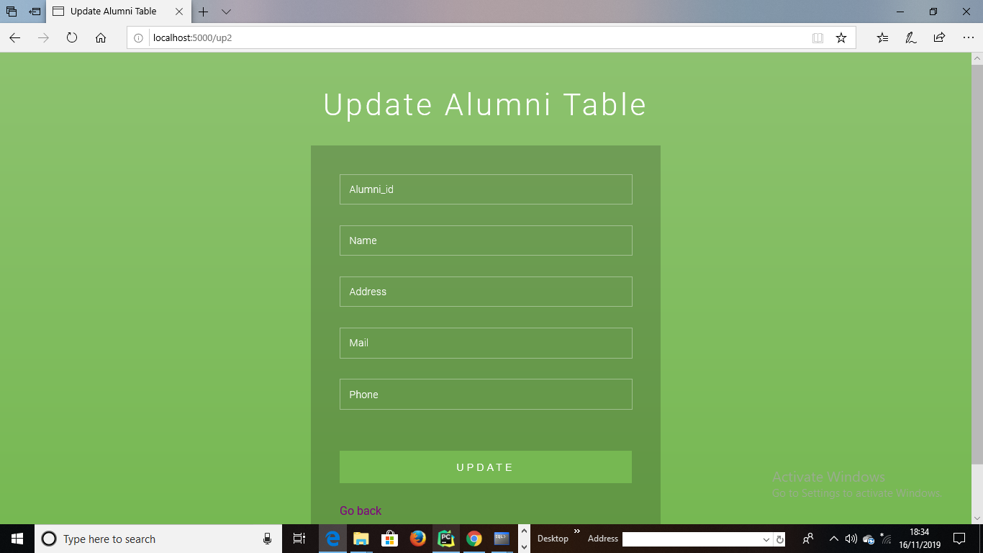

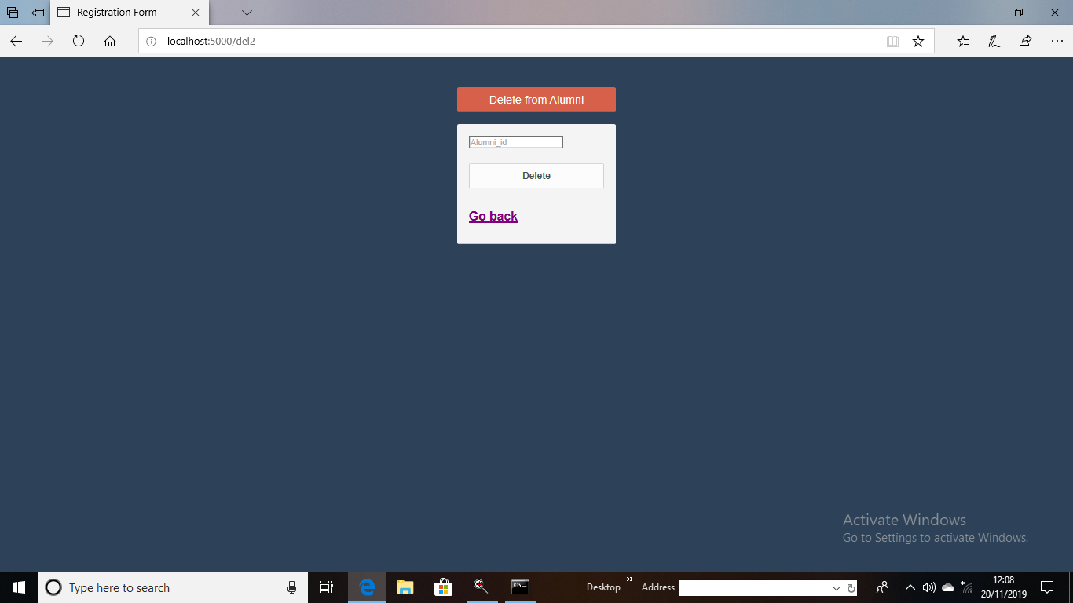



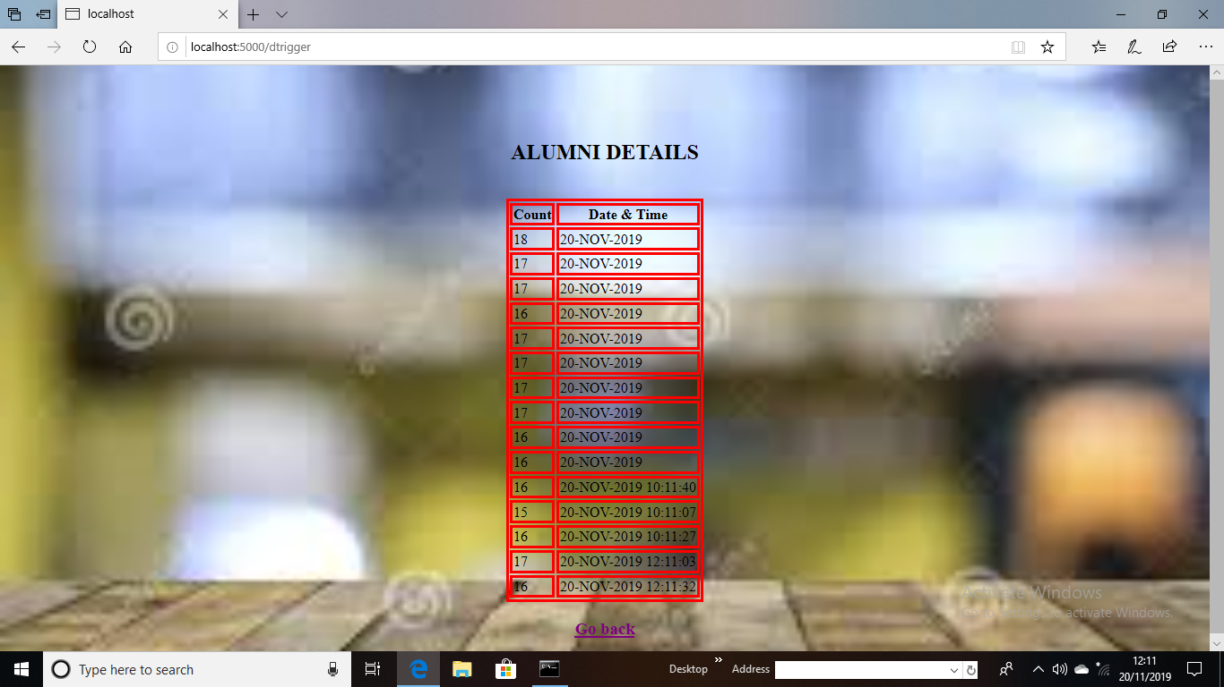

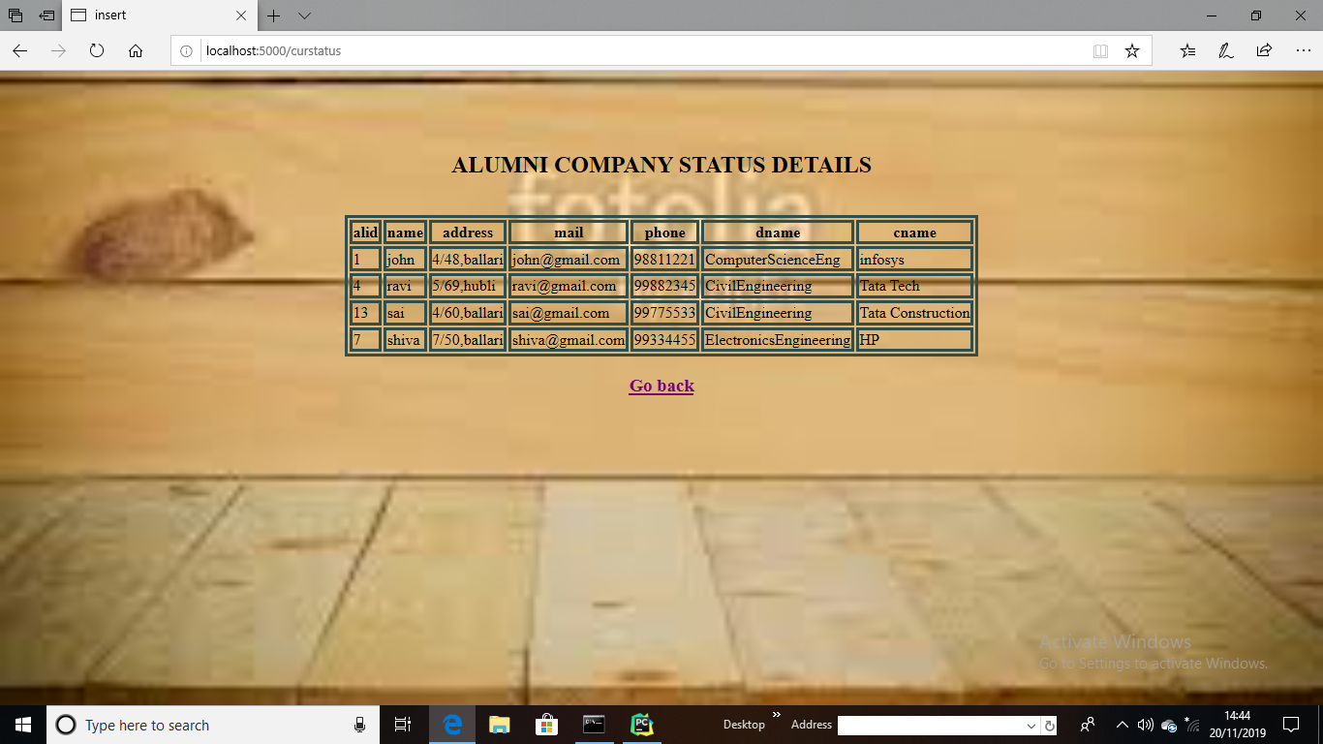

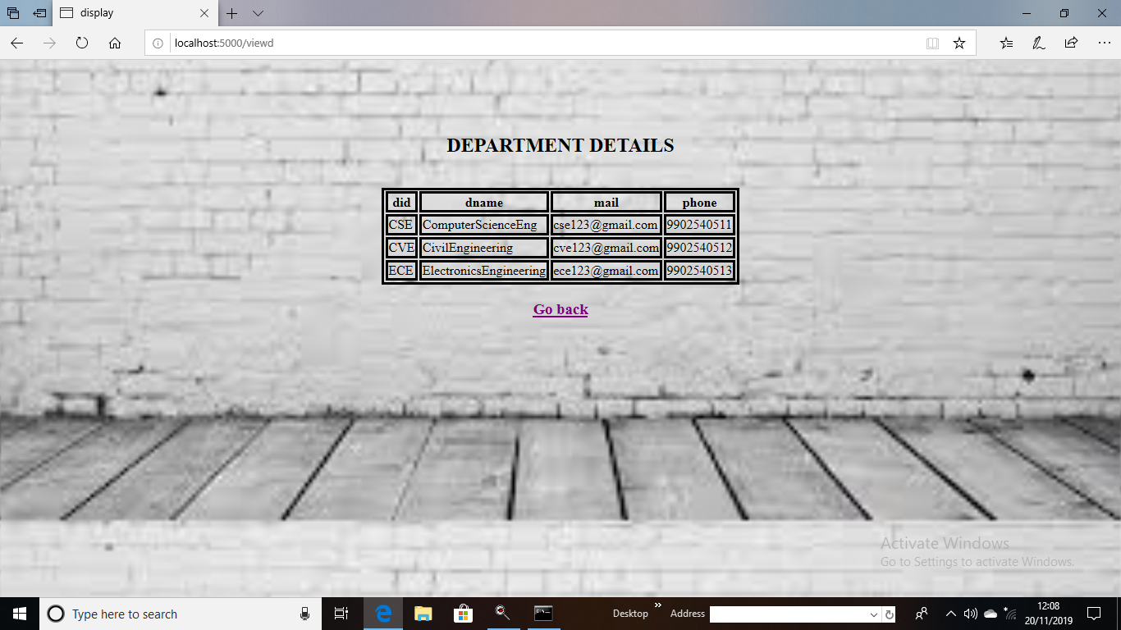

**CHAPTER 4**

**CONCLUSION:**

**The application is available for a particular college which is handled by single user. People who knows username and password they are allowed to access the application. The visitor can look at the graduates profiles the level of profile details shown is limited.**

**The graduates details can be inserted, updated, deleted or can view the details of alumni who are currently undergoing trainings, accurately working in respected companies and perceiving higher studies. The details of graduates are used by the college to conduct alumni get together, getting help from graduates about current market status, job opportunities.**

**The people are usually main abundant to dig their goals as we take their own shadow for our own experience processes.**

**­­**

**REFERENCES**

[1] Introducing Python ,”Modern Computing In Simple Packages”, O’REILLY

[2] A Ramakrishna Gehrke , “Database Management Systems”, Mc GRAW - HILL publications Third Edition .

[3] Ramez Elmasri , Shamkant B. Navathe , “Fundamentals of Database Systems” Seventh Edition, Pearson .